# INTRODUCTION

* 1. Overview

Retailing encompasses the business activities involved in selling goods and services to consumers for their personal , family, or household etc. A CRM product owner has requested to create two applications, one is a sales app for sales reps to use this application and store customers data and the second application is service app for service reps/agents to provide support to customers in dealing cases.

I

* 1. Purpose

* Sales force can be used to manage orders from retail stores and distributors including tracking orders, processing , payments, and managing inventory levels.

* We provide a wide range of services that can be tailored around retail sales force management to help organization achieve their goals and focus on custom needs.

1. **Problem Definition& Design Thinking**

2.1 EMPATHY MAP 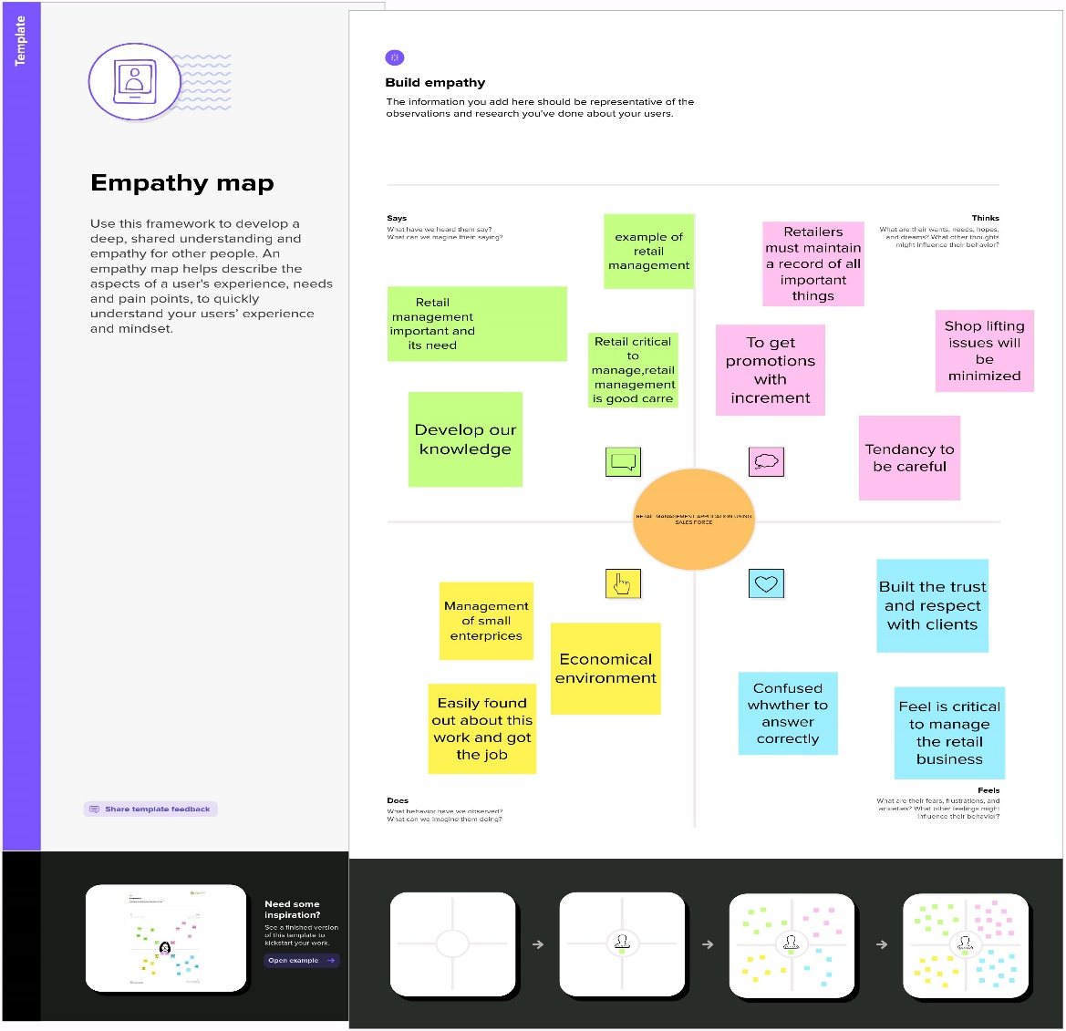

2.2 Ideation & Brainstorming Map

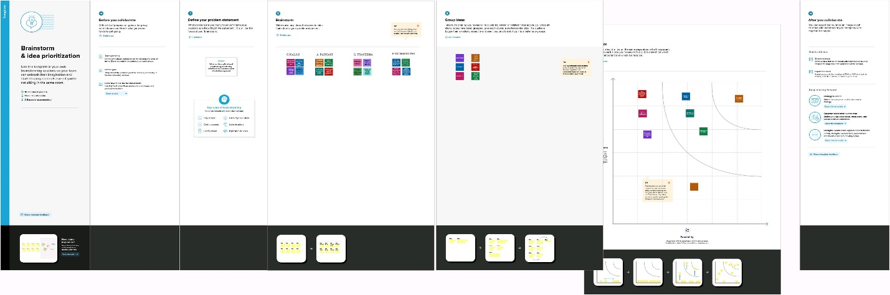

PastetheIdeation&brainstormingmapscreenshot

**3 RESULT**

* 1. DataModel:

|  |  |
| --- | --- |
| **Object name** | **Fields in the Object** |
| Dispatch/tracking | |  |  | | --- | --- | | Field label | Data type | | Tracking id | Text | | Dispatched | Text | |
| Validation rules | |  |  | | --- | --- | | Field label | Data type | | Account | Formula | | Contact | Formula | |

# Activity & Screenshot

Milestone-1:

Login to Your Sales force Account

# 

# Milestone-2

Activity 1

Creation of object Dispatch/Tracking

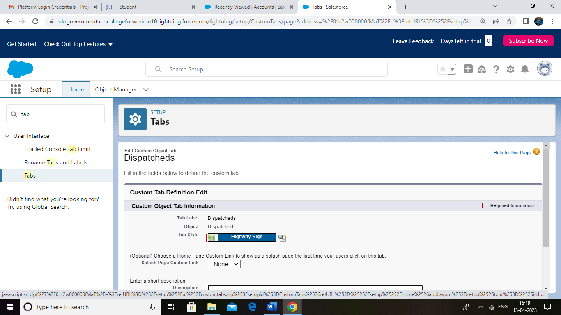

Activity-2

Fields available on Dispatch/tracking

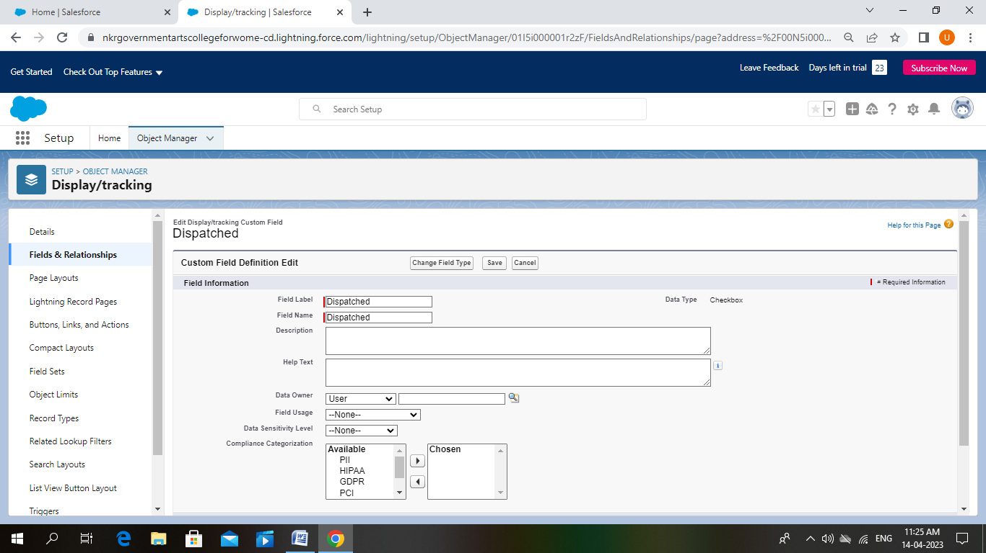

Milestone-3

Relationship b/w objects:

Activity-1:

Creation of relation between objects

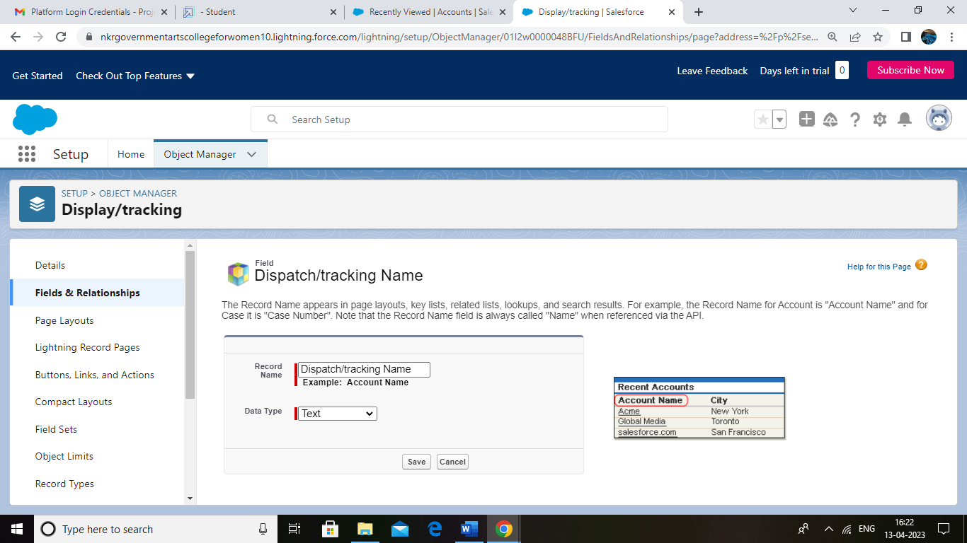

Milestone-4

Application:

Activity-1

Creation of application

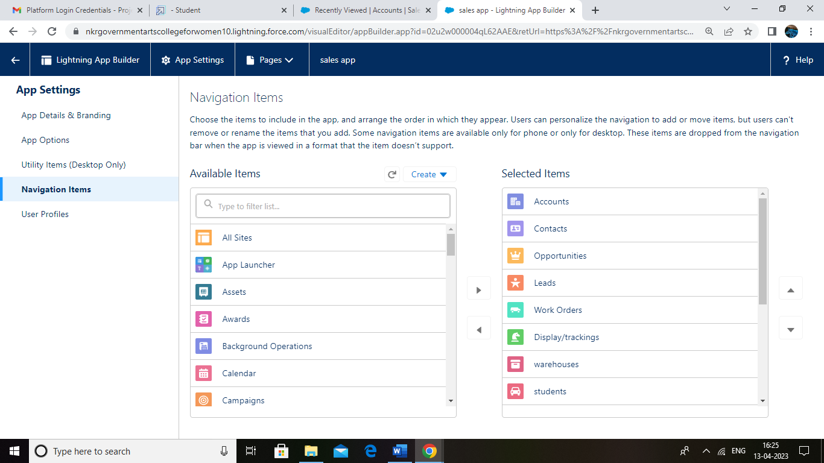

Milestone-5

Layouts:

Activity-1

Creation of custom tabs

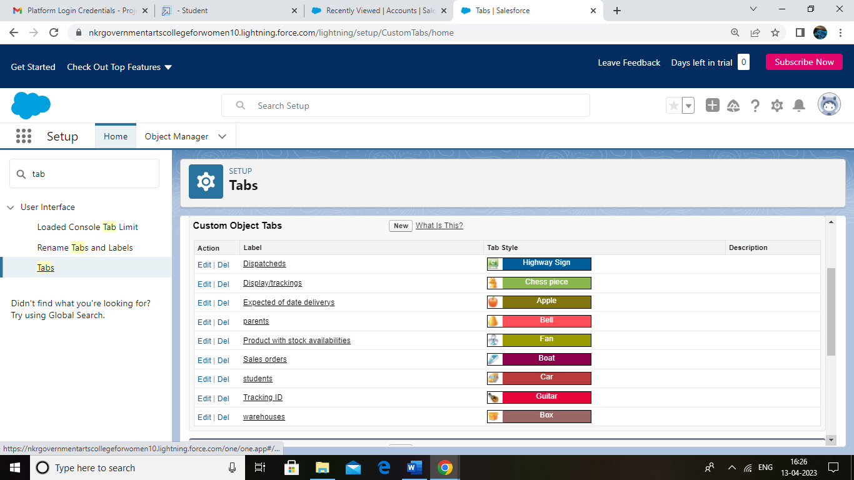

Milestone-6

User:

Activity-1

Creation of user

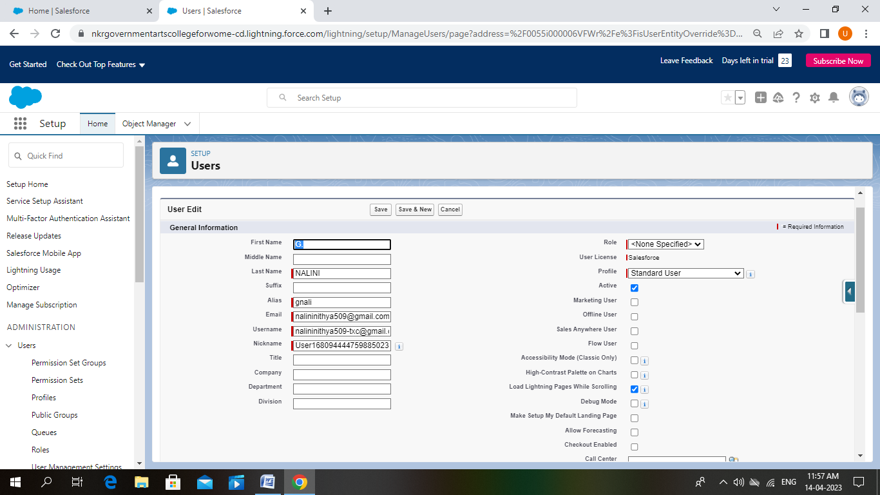

Milestone-7

Validation Rules:

Activity-1:

Creation of validation rule

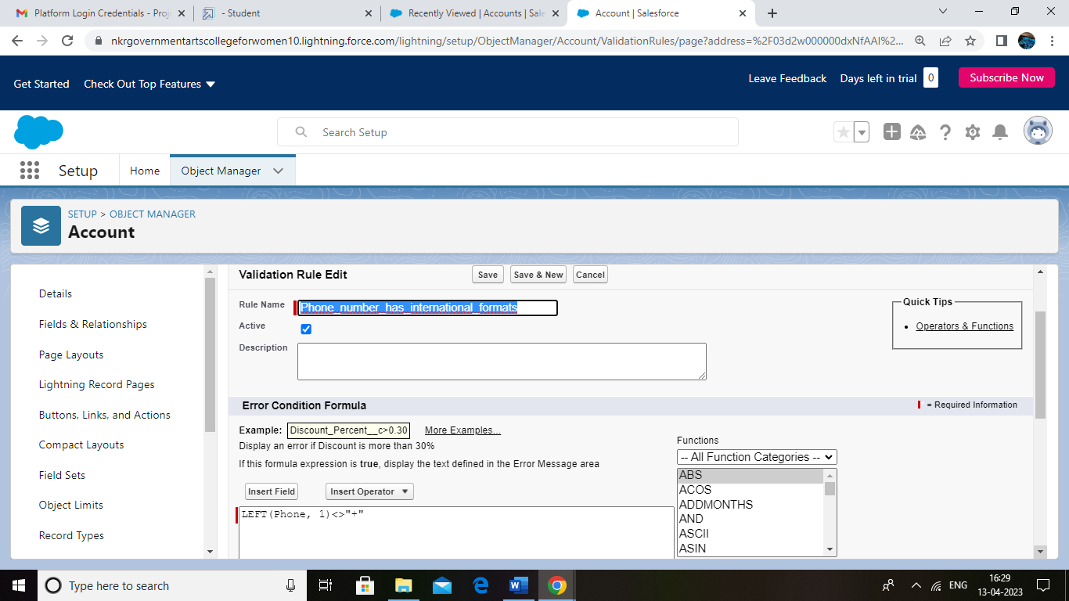

Activity-2:

Creation of cross object formula

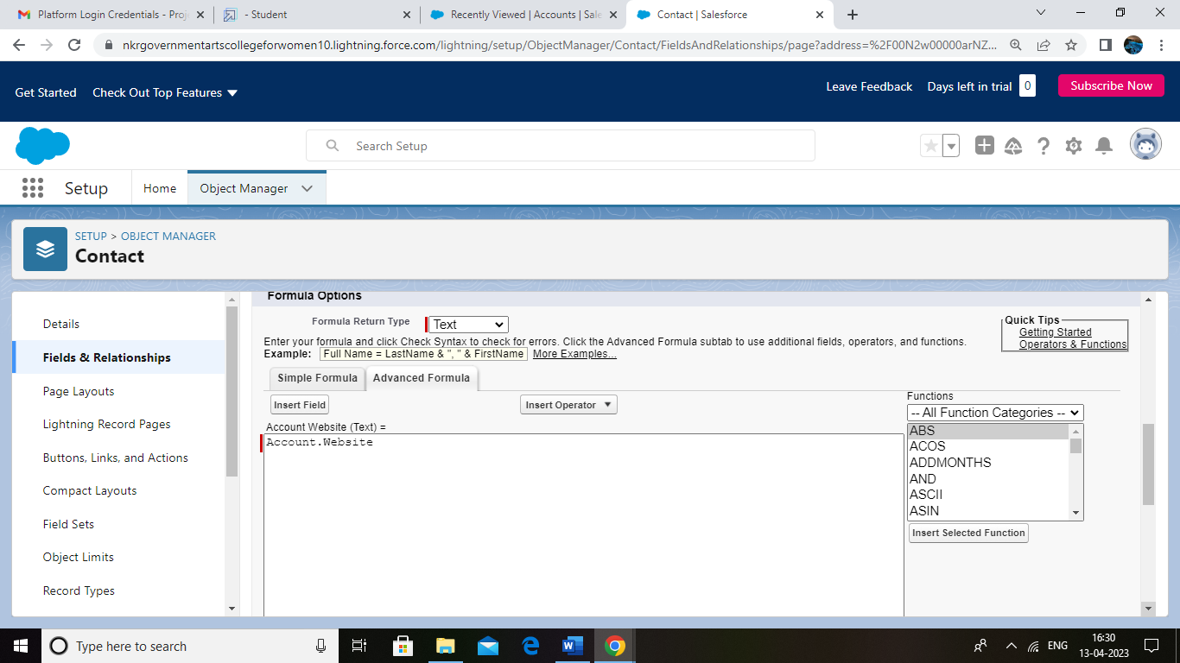

Milestone-7

Reports

Activity:

Creation of report

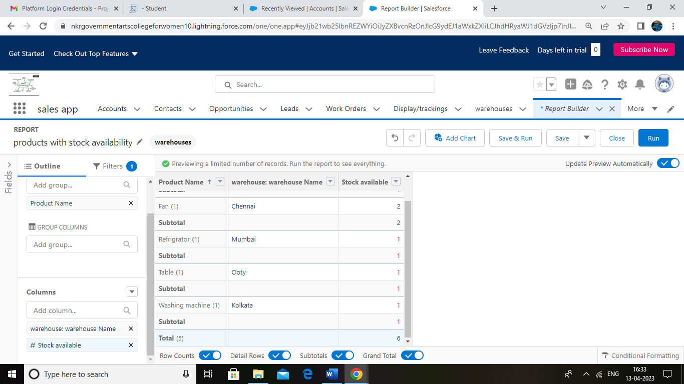

Milestone-8

Dashboards:

Activity

Creation of Dashboard

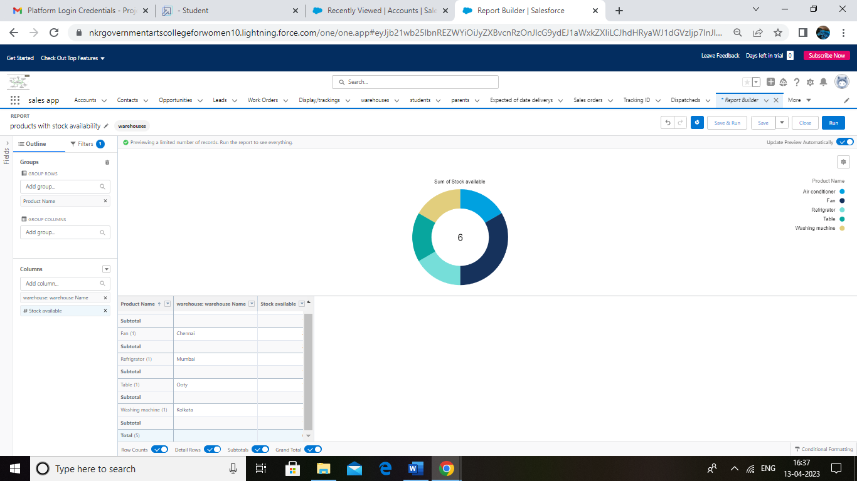

# TrailheadProfilePublicURL

# Team Leader :https://trailblazer.me/id/unalinig

# Team Member 1:https://trailblazer.me/id/aparkavi

# Team Member 2:https://trailblazer.me/id/cpravin1

# Team Member 3:https://trailblazer.me/id/pindhumathi

**5 ADVANTAGES&DISADVANTAGES**

**ADVANTAGES**

# Requires less capital

# More profit margin than wholesalers

# Better customer relation

# Credit facility

# No liability towards the buyers

# DISADVANTAGES

# More marketing coasts

# Requires Good selling skill is required

# High competition

# No benefit of bulk buying

# 6 APPLICATIONS

* It helps to store custom data which the retailer can then use to reach out of customers.

* Through email with personalized offers or with mail offers.

* When at the check –out process retailers can search up the customers information to make their experience efficient and quick.

# 7 CONCLUSION

* Retailing thus enjoys many unique features inefficiency in retailers leads to lower profitability of the retailers and lower service outputs for consumers.

* Steps to strengthen the position of the retailing industry must be taken. Such steps may include establishment of retailers cooperatives, merger and buyout.

* Use of technology to the greatest possible extent , setting up of non-store retailing centers and increase in franchise network.

# 8 FUTURE SCOPE

* The future of retail will feature a high level of online penetration. The best suppliers will establish direct to consumer relationships , where retailers will no longer save as the gatekeeper to the customer.

* Retailing has a very wide scope. It is one of the fastest growing industries in India and is providing employment opportunities to many people with the increase purchasing power of the people.